Server setup: (for adding the html and php files)

1. download filezilla here: <https://filezilla-project.org/download.php?show_all=1>

2. host is sftp://144.13.22.59

3. log into stout VPN

4. username is agileg5

5. password is aexpKiran

6. port is 22

for working on the server (adding php files, etc.)

1. click agileg6 folder

2. click www folder

3. drag and drop the files you want to add (php, html, etc.) into where the red arrow is.

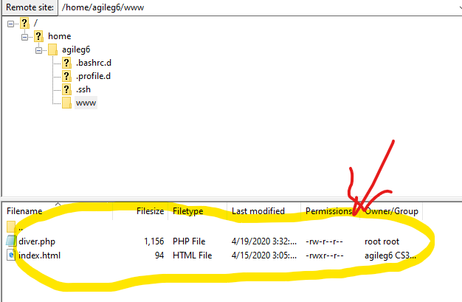

Filezilla extra setup:

If you would like to avoid dragging dropping your file from your project folder into filezilla a thousand times, you can first set up the editor function with filezilla:

1. Go to edit -> settings
2. Click the File editing option and click the filetype associations:
3. Click “use custom editor:” and “always use default editor”
4. Find your VS code .exe file

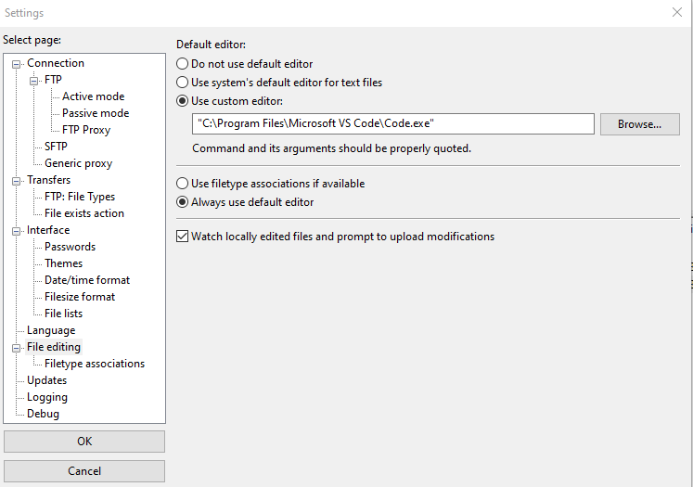

1. Now, you can right click on the file you’d like to edit, and click the “View/Edit” option

-this will open VS code and you can edit it directly on the server.

-after editing, every time you save on VS code, this will open a prompt on filezilla called “file has changed”

-click “yes”

-you can now refresh your page on he<http://144.13.22.59:85/> and it will show your edits

-you can keep editing, saving, and confirming from here.